**DOORWAY GROCERY CATALOGUE**

*A*

*Mini Project Report*

*Submitted in partial fulfilment of the*

*Requirements for the award of the Degree of*

**BACHELOR OF ENGINEERING**

IN

**INFORMATION TECHNOLOGY**

By

**<V.SWETHA><1602-19-737-118>**

**<K.RUSHITHA><1602-19-737-090>**



**Department of Information Technology**

**Vasavi College of Engineering (Autonomous)**

**(Affiliated to Osmania University)**

**Ibrahimbagh, Hyderabad-31**

**2020**

**Vasavi College of Engineering (Autonomous)**

**(Affiliated to Osmania University)**

**Hyderabad-500 031**

**Department of Information Technology**



**DECLARATION BY THE CANDIDATE**

We, **K. Rushitha and V.Swetha,** bearing hall ticket number, **1602-19-737-090 and 1602-19-737-118**, hereby declare that the project report entitled **DOORWAY GROCERY CATALOGUE** Department of Information Technology, Vasavi College of Engineering, Hyderabad, is submitted in partial fulfilment of the requirement for the award of the degree of **Bachelor of Engineering** in **Information Technology**

This is a record of bonafide work carried out by us and the results embodied in this project report have not been submitted to any other university or institute for the award of any other degree or diploma.

**K.Rushitha**

**1602-19-737-090**

**V.Swetha**

**1602-19-737-118**

(Faculty In-Charge) (Head,Dept of IT)

**ACKNOWLEDGEMENTS**

We would like to take this opportunity and thank everyone who have helped me in completing this project.

First of all we would like to express our special thanks of gratitude to our faculty in-charge D. Prasanna as well as our Hod and Vasavi College of Engineering who guided us along the project and doing the project in an appropriate manner and by giving us this golden opportunity to do this project “DOORWAY GROCERY CATALOGUE”.

This helped me in knowing about the various concepts of C Programming Language , which I haven’t known before and helped us to do lot of research in C Language. It helped us in deliberating our thoughts about the concept and to enhance our coding skills .

Secondly, I would also like to thank few websites and you tube channels which I visited when I was doing my project .They have really taught me know the amazing program skills where you can make your project more flexible with many possible use cases.

Any attempt at any level can't be satisfactorily completed without the support and guidance of our friends.

We would like to thank our friends who helped us a lot in gathering different information, collecting data and helping us from time to time in making this project, they gave me different ideas in making this project unique.

**K.Rushitha**

**1602-19-737-090**

**V.Swetha**

**1602-19-737-118**

**ABSTRACT**

Grocery shopping is one of the most frequently occurring tasks in our daily life, and it is observed that most of the people prefer supermarkets in order to purchase their required items. In the Supermarkets we usually see huge number of customers rushing around and we go clueless where our available item is present. Yes ,everyone might have experienced this. As touch screen monitors serve many people and are becoming an integral part of human life.

Digital grocery list can be introduced at the entrance of a supermarket by creating an application which gives the complete list of all the items available in the store. It is a digital grocery list that can be used by group of members in the store and it will be easy to operate for any individual .The application consists of several modules where the user can approach the item category wise , including the price and discounts on the item, location of the product in the store , availability etc. and many more features can be implemented further .Also we have this special feature in our application where the user/customer can provide a review on the store and he can be rewarded with the prize money which will be later transferred to his account. As it is a console based language we have included few colour effects too.

The “DOORWAY GROCERY CATALOGUE” is a challenging project and a concept which is not only based on Social lifestyle but also on the technology.

**TABLE OF CONTENTS**

1. **Introduction………………...............................................6**
   1. Problem domain…………………………………..6
   2. Objective………………………………………..7
   3. List Of Features…………………………………8
2. **Technology………………………………………………9**

2.1 Software Requirements…………………………9

2.2 Hardware Requirements……………………9

1. **Proposed Work…………………………………………10**

3.1Design………………………………………………..10

3.1.1 Use Case Diagrams………………10

3.2.2 Flow Charts………………………..11

3.2 Implementation…………………………………….14

3.2.1 Description of main modules…………………14

3.2.2 Highlighting Features of Application……………18

3.2.3 GitHub Links……………………………20

3.3Testing………………………………………………21

1. **Results…………………………………………………25**
2. **Additional Knowledge Acquired………………………28**
3. **Conclusion and Future Work………………………….29**
4. **References…………………………………………….30**

**1.INTRODUCTION**

**Offline shopping** is a traditional way of purchasing services or products by directly visiting to the store/shop/ or vendor. This project is a monitor based application for an existing shop. The project objective is to deliver a clear idea over the shop items and their prices locations etc. Offline shopping is the process whereby consumers directly buy goods or services from a seller in real-time, without any intermediary service. It is a form of electronic commerce. This project is an attempt to provide the advantages of offline shopping to customers of a real shop.

**1.1 PROJECT OBJECTIVE**

The objective of the project is to make an application at the entrance platform to purchase items in an existing shop. In order to build such an application complete web support need to be provided. A complete and efficient web application which can provide the whole idea of the store is the basic objective of the project. This application can be implemented in the form of an app in the monitor screens too. Our first try made it to console programming only but not a web based one.

**1.2 Purpose**

“DOORWAY GROCERY CATALOGUE” is a project in which it helps to overcome problems faced in offline shopping.

In this a digital grocery list can be introduced at the entrance of a supermarket by creating an application which gives the complete list of all the items available in the store. It is a digital grocery list that can be used by group of members in the store and it will be easy to operate for any individual .The application consists of several modules where the user can approach the item category wise , including the price and discounts on the item, location of the product in the store , availability etc.

Here the DOORWAY GROCERY CATALOGUE provides them the information about the availability of the product So , one need not waste there time in searching the product which is not available . As it also provides the location of the product ,it is easy for one to search a product. so ,we can say that DOORWAY GROCERY CATALOGUE will save our time and energy.

**1.3 Uses**

**Quality Time -** Shopping at a store lets you get close to your potential assets and shop at your own leisure. You get to examine a variety of choices and buy the one that you like most...

**Touch & Feel -** As I mentioned before, getting to know the product you’ll be buying is almost therapeutic and allows to you inspect the products closely for any well-hidden damages or defects. This way, you know that you won’t be getting any surprises after making your purchase.

**Salesman -** So, you’ve just searched the entire store and found two very different, but equally great items and can’t decide which to pick (even if your life depended on it). You can’t get google it because your mobile internet connection sucks, but that’s okay! The in-house salesman can tell you about each item and help you make an informed decision.

**Instant Purchase -** You don't have to wait for days to get the product. Once you choose the right product suitable for yourself, make the payment and take it home.

**Return/replace -** Let’s say you're not satisfied with your purchase, you can always go back to the store to get a replacement or refund. No more waiting ‘3-5 business days for the amount to appear as a credit in your next billing statement.’

**Exhaustion -** You might spend the whole shopping day and still not find what you are looking for. Shopping for long hours is fun, but only as long as you find something worth taking home!

**Expensive -** Most physical stores don’t accept online coupons. Sometimes, you may also end up paying more for an item than what it’s worth. Depending on the size of the item, transportation can be an additional cost too.

**Crowds -** Shopping in a crowded place with sweaty people can be an introvert’s (or a germaphobe’s) worst nightmare (especially if you hate shopping and are being forced to tag along). Nobody wants to rub elbows while waiting in queue at the billing register.

**1.4 List of Features in this project**

In this project the manager can add, delete items, update offers by adding the new offers and deleting them if they are expired ,Also he can view the review of the customers. From the customer end he can search a product ,view all the categories, check the offers , can review the store .

**1.4.1 CUSTOMER’S FEATURES**

**1.4.1.1 Search A Product**

The customer can search a product by choosing the option and get the location,

price if ,it is available.

**1.4.1.2 Display Categories**

List of all the items of that Category are displayed

**1.4.1.3 View Offers**

Customer can view all the mega offers available in the store

**1.4.1.4 Review**

Customer needs to enter the details inorder to avail the cashback offers

**1.4.2 MANAGER’S FEATURES**

**1.4.2.1 Add Items**

Add items into the cart by entering their whole details

**1.4.2.2 Delete Items**

Delete items if the quantity is over from the cart .

**1.4.2.3 Offers**

Can add and delete offers available in the store.

**2.TECHNOLOGY**

The software and hardware requirements for the project are:

**HARDWARE REQUIRMENTS**

* Processor : Intel (IR) Core(TM) /Ryzen.
* Processor Speed : 250 MHz to 833MHz
* RAM : 512MB to 1024 MB
* Hard Disk : minimum(2GB ) to 30GB
* Standard Input : (QWERT)Key Board
* System Type : 32-bit processing system(can be more)

**SOFTWARE REQUIRMNETS**

* Software **:** gcc compiler
* Language : C Programming Language
* Operating System : Windows XP (or greater version)/Linux
* Web Technologies : Console based project

**3.PROPOSED WORK**

**3.1DESIGN**

Our main idea in doing this design is to give a brief overview what our application portrays

on the whole.

**3.1.1 USE-CASE DIAGRAM**

Use case diagram gives an idea about the use cases in the project and to whom they are linked

is clearly explained

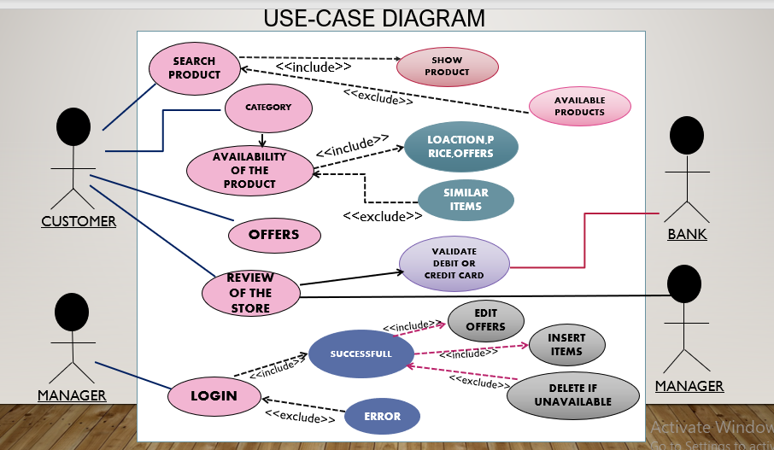

**3.1.2 FLOWCHART**

**3.1.2.1 Flow Chart 1**

This flowchart is the overall view from the manager’s end and customer’s end and detailed explanation of it is explained in 3.2.2

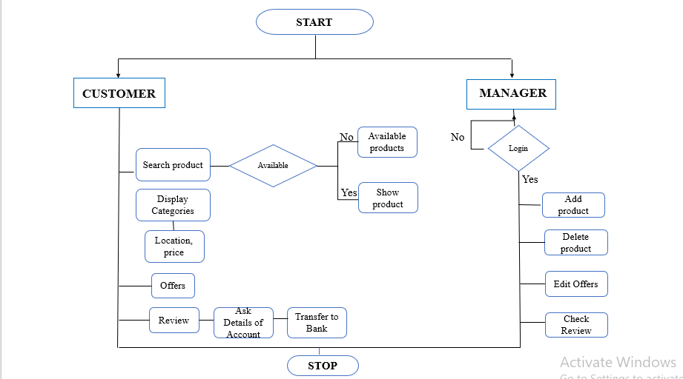

**3.1.2.2 FLOW CHART 2**

This flowchart gives the detailed view of an original flowchart which we do in C Language.

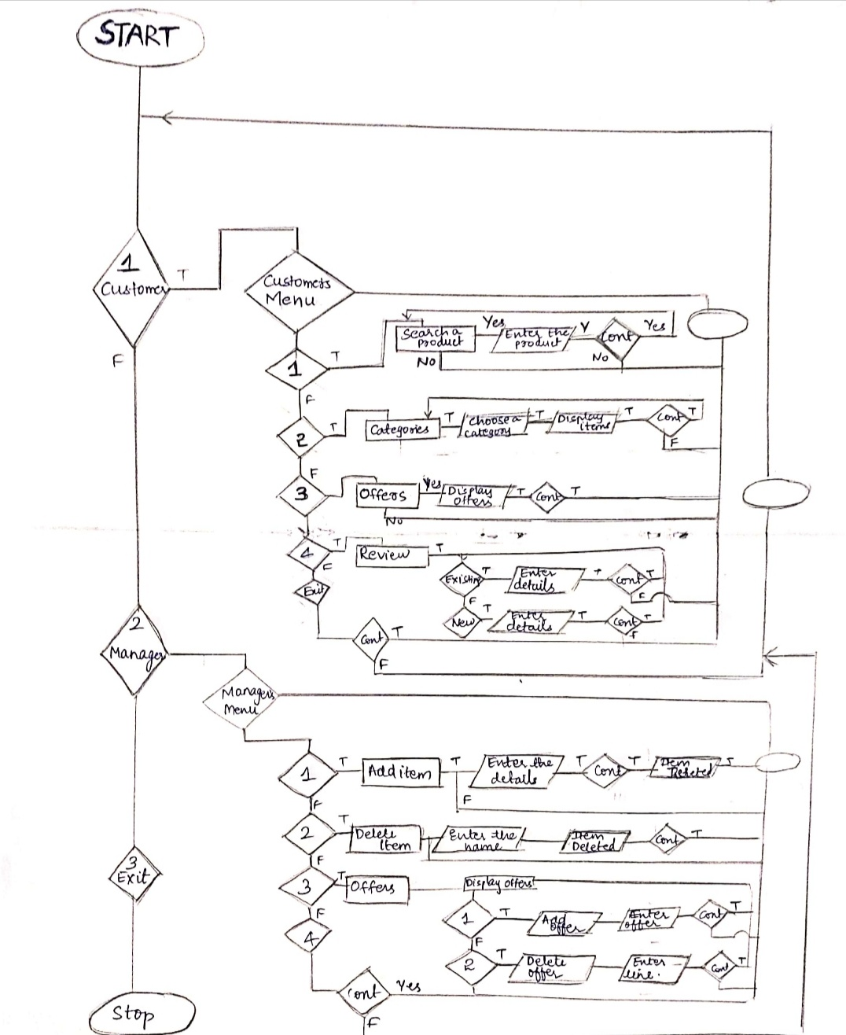

**3.2 IMPLEMENTATION**

**3.2.1 USE CASE DESCRIPTION**

**3.2.1.1 Categories**

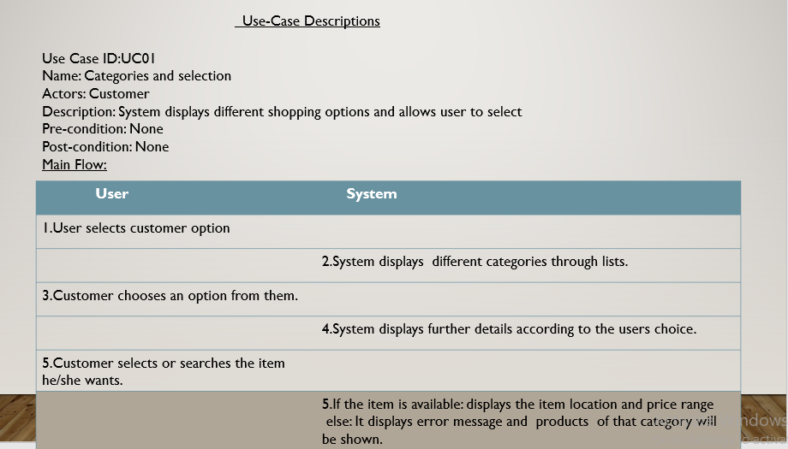

In this module(categories and selection) system displays the different shopping options and allows user to select.

**3.2.1.2 Offers**

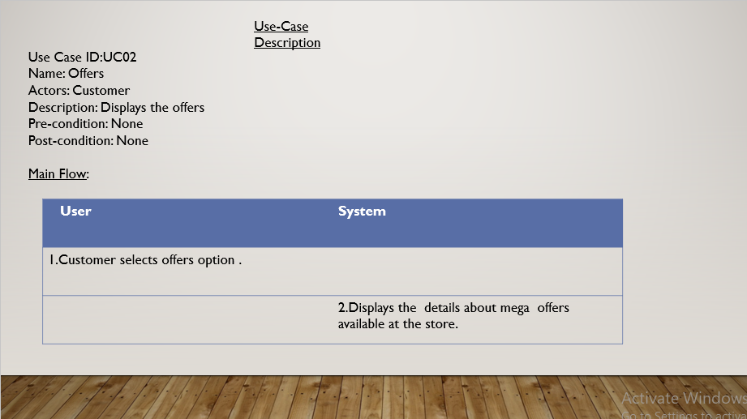

Offers module in which system displays the mega offers available in the store

**3.2.1.3 Review**

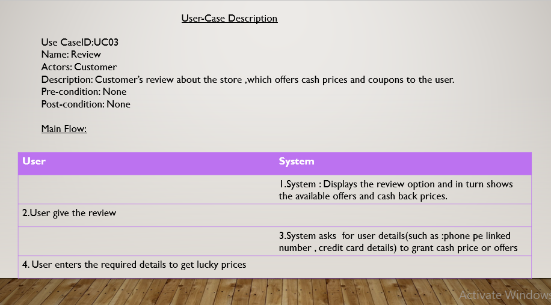

Review module takes the review of the customer and stores in file .it can be seen by manager

**3.2.1.4 Login And Update Items**

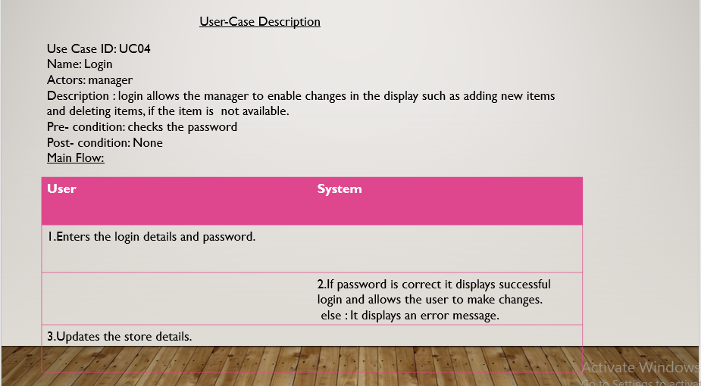

If manager wants to enable changes in display he want to login, if the login is successful then he can make changes.

**3.2.1.5 Search a product**

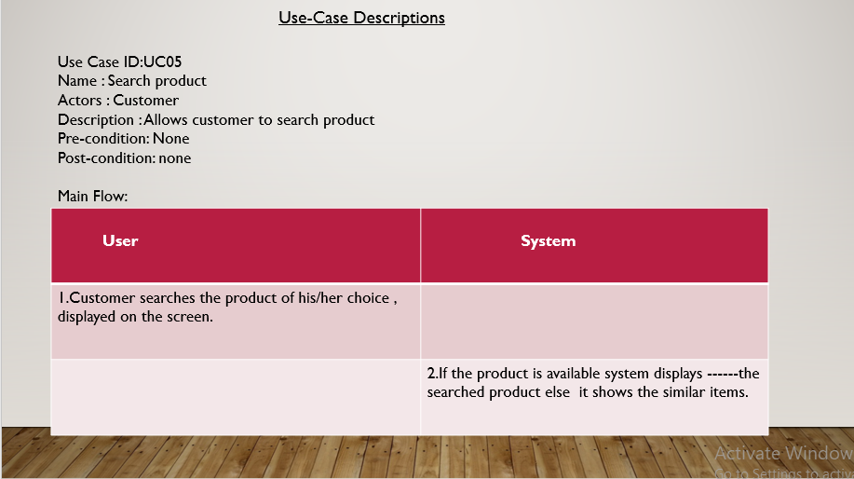

In this module **search** customer is allowed to search a product .if the product is available in the store it will display the product details. else it displays not available message

**3.2.1.6 Edit Offers**

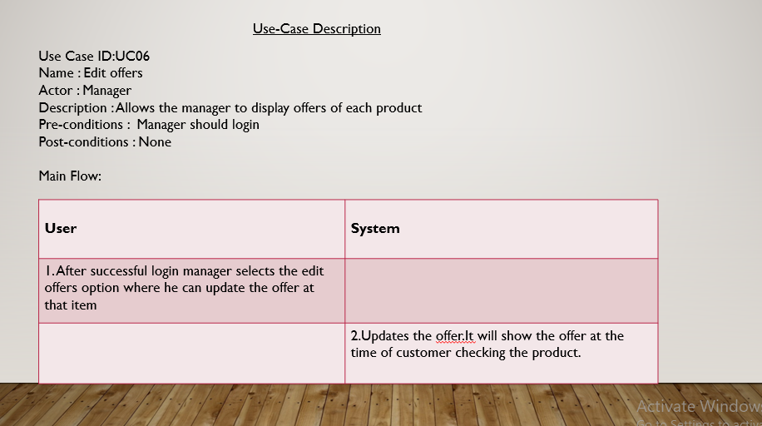

Edit offers is a module in which manager can edit and update the offers of the store**.**

**3.2.2 SPECIFIC ALGORITHM**

They are few function which we would like to mention ,that helped us in approaching the program easier and with less complexity.

** Remove all occurrences of a given word in string.

void removeAll(char * str, const char * toRemove)

{

int i, j, stringLen, toRemoveLen;

int found;

stringLen = strlen(str); // Length of string

toRemoveLen = strlen(toRemove); // Length of word to remove

for(i=0; i <= stringLen - toRemoveLen; i++)

{

/* Match word with string */

found = 1;

for(j=0; j < toRemoveLen; j++)

{

if(str[i + j] != toRemove[j])

{

found = 0;

break;

}

}

/* If it is not a word */

if(str[i + j] != ' ' && str[i + j] != '\t' && str[i + j] != '\n' && str[i + j] != '\0')

{

found = 0;

}

/*

* If word is found then shift all characters to left

* and decrement the string length

*/

if(found == 1)

{

for(j=i; j <= stringLen - toRemoveLen; j++)

{

str[j] = str[j + toRemoveLen];

}

stringLen = stringLen - toRemoveLen;

// We will match next occurrence of word from current index.

i--;

}

}

}

**3.2.3 GITHUB LINKS**

We have segregated the files of our project into folders namely - Code and Files. Code folder contains the main C file and the Files folder contains the data files (.txt format) which we used in our project. Our repository also contains a README file which has a brief description of our project.

GITHUB LINKS:

<https://github.com/RushithaK/DGC>

https://github.com/Swetha118/Doorway_Grocery_catalogue

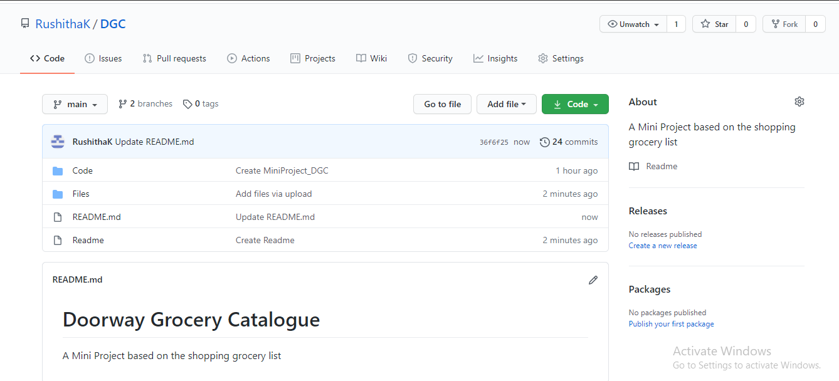

**Files**

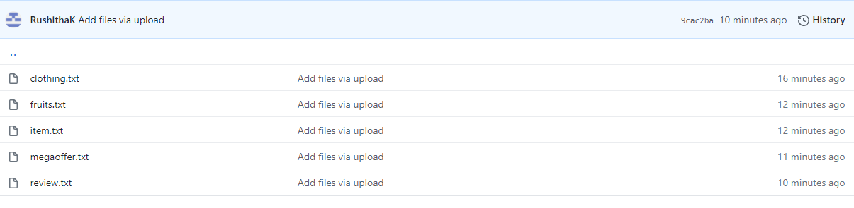

**Code**

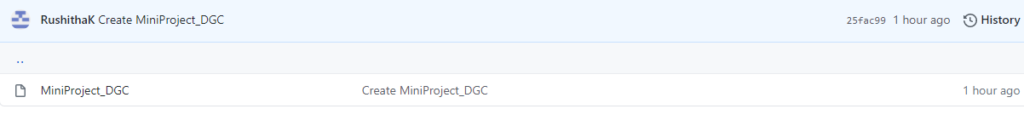

**3.3TESTING**

1. 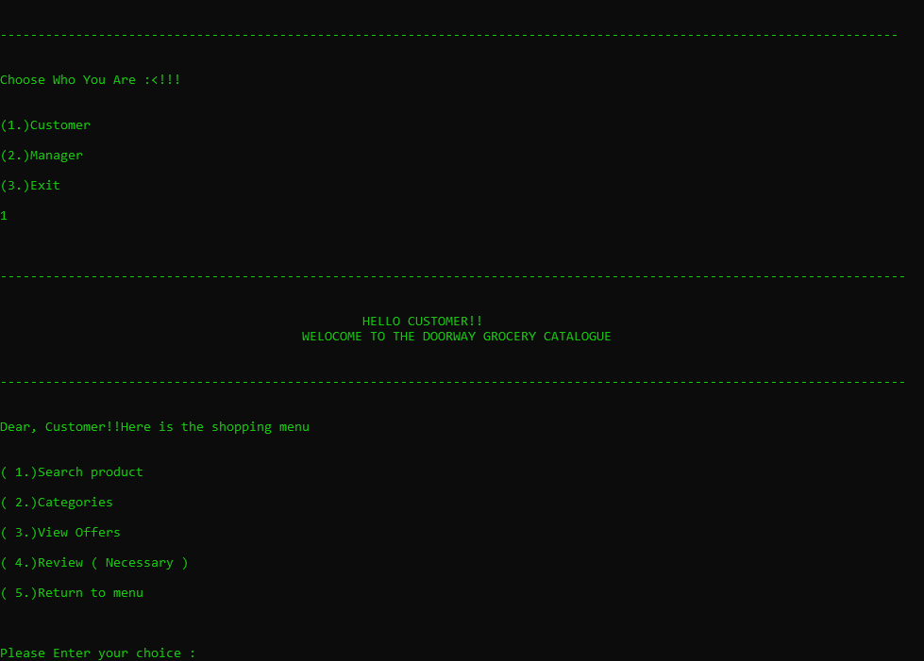
2. 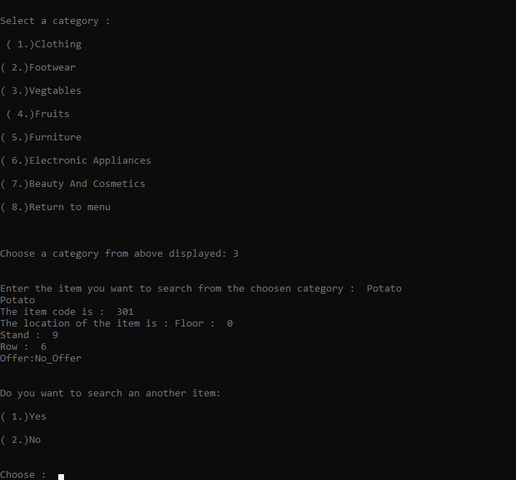
3. 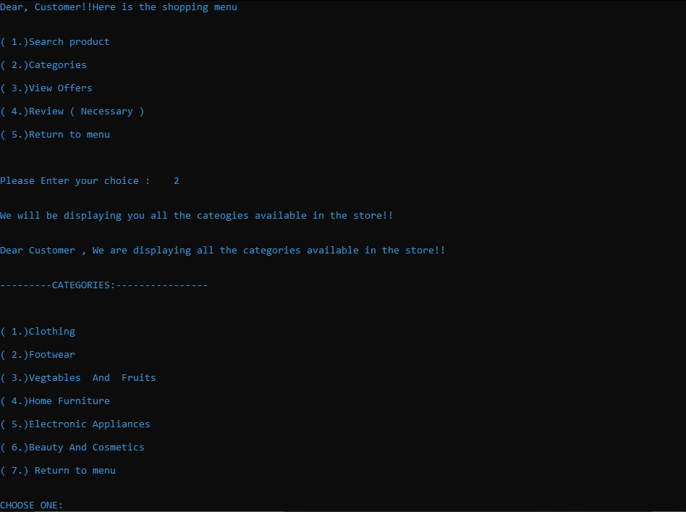
4. 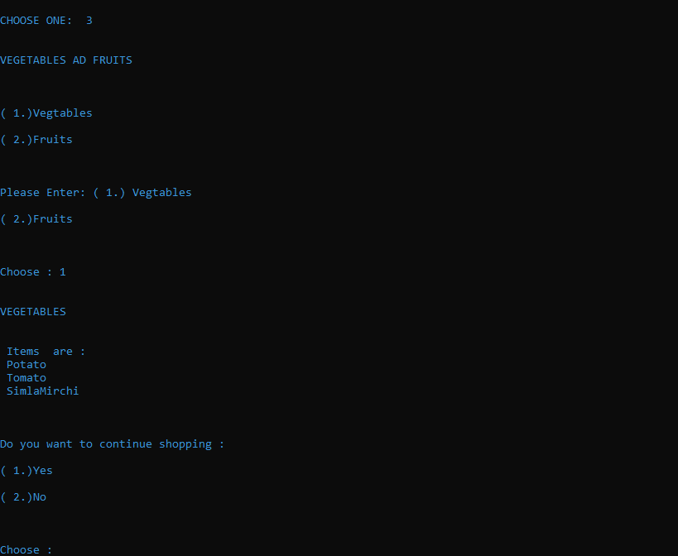
5. 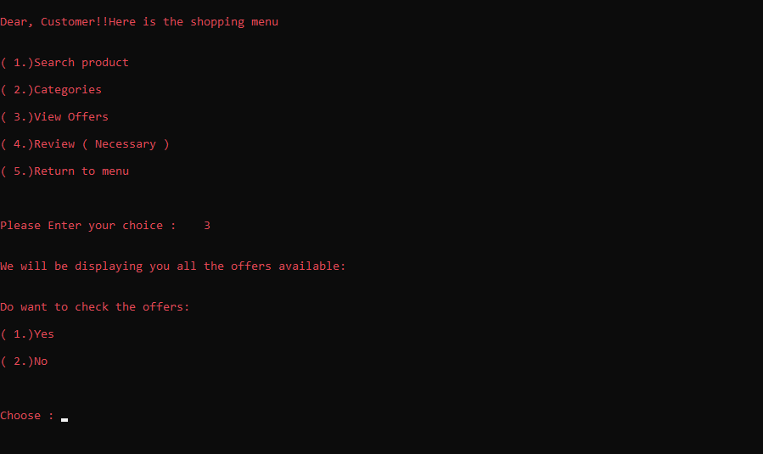
6. 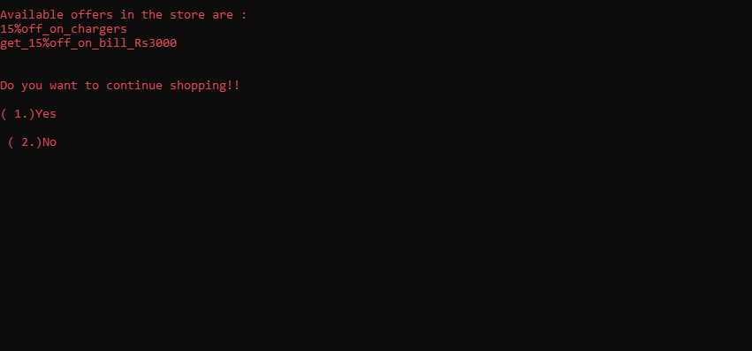
7. 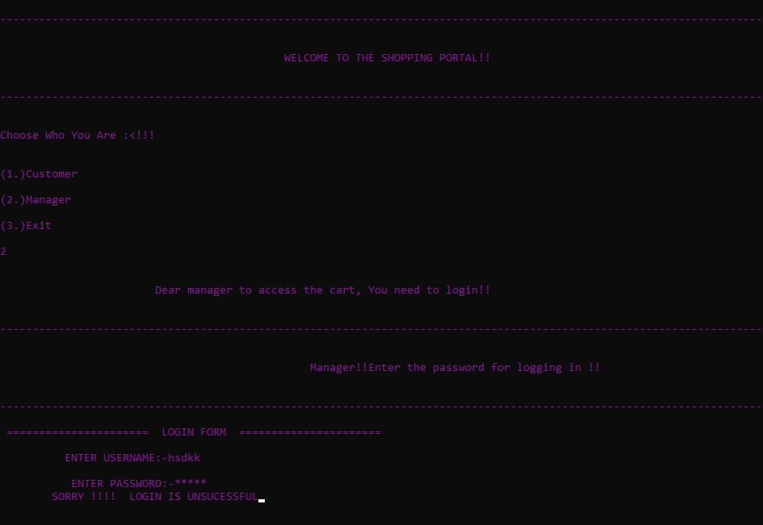
8. 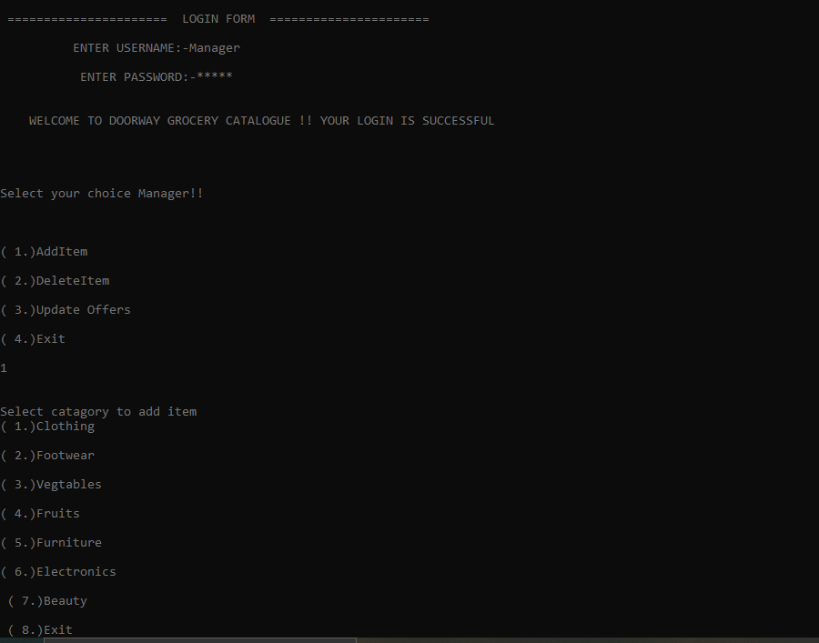

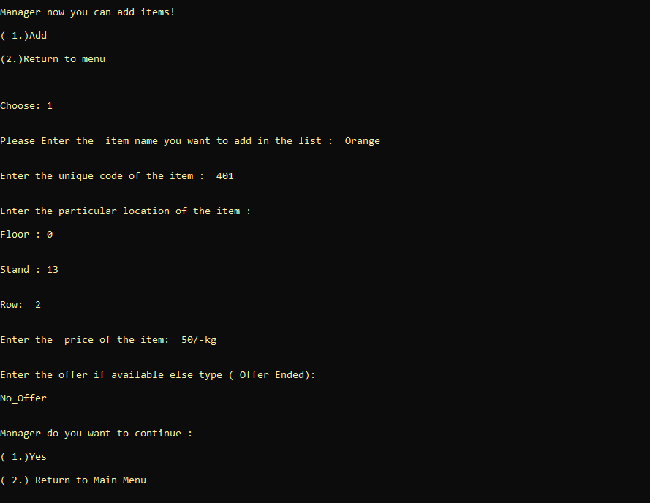

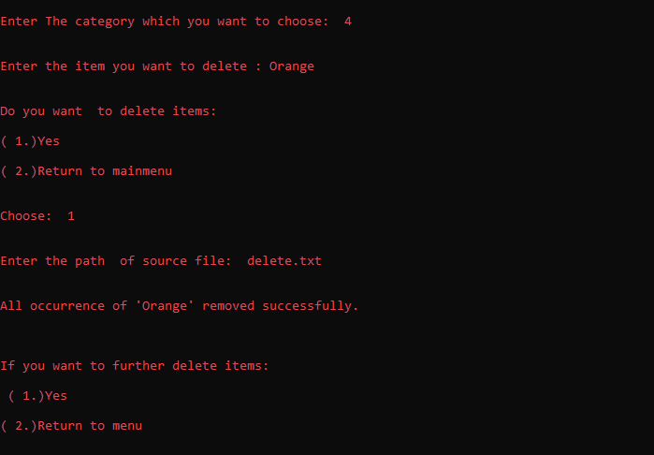

**4.RESULTS**

Our project ‘Doorway Grocery Catalogue’ is a unique idea ,it may be similar to the online shopping but it is far away different too. We basically provide manager the option to update offers which is different from other systems. Also we have review system where the user can avail cashback offers.

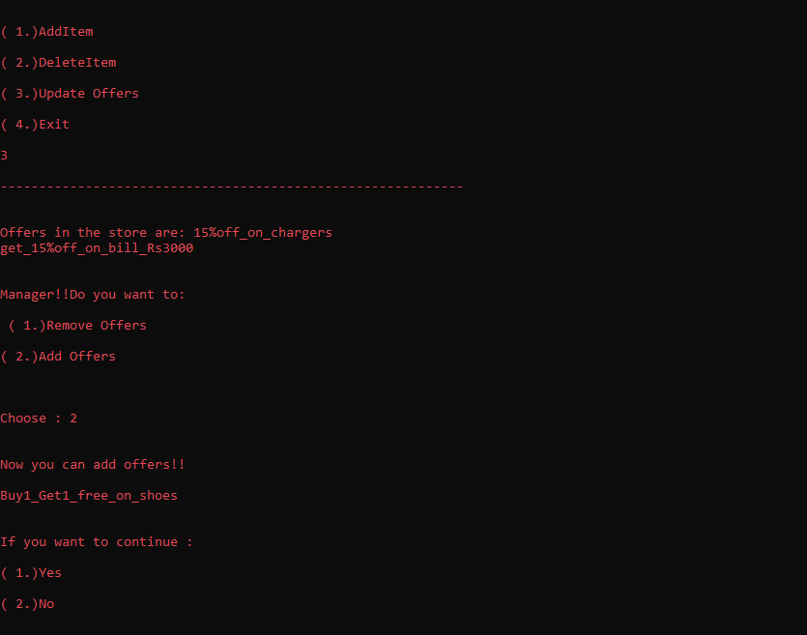

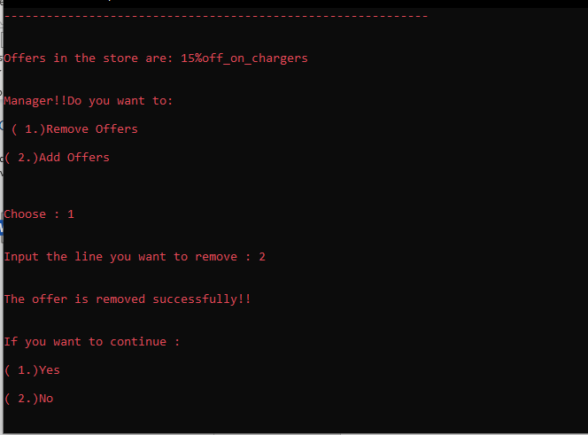

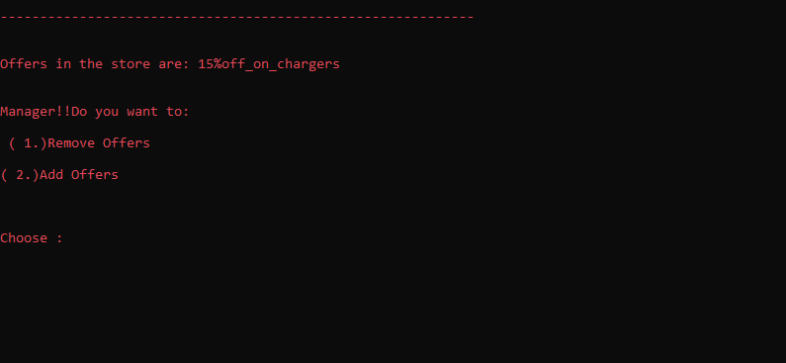

**Review of the store**

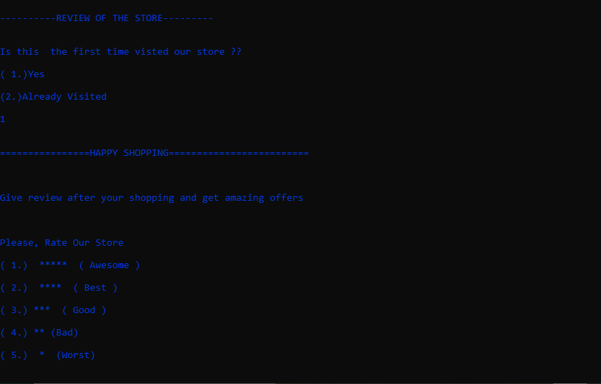

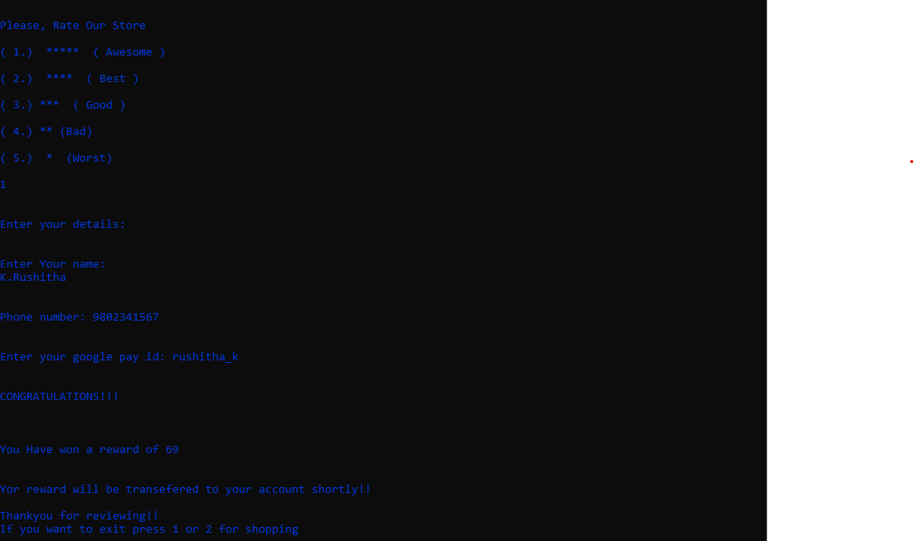

**5.ADDITIONALLY WHAT WE LEARNT**

This project helped us in gaining valuable information and practical knowledge on several topics like implementing files and use of different libraries in c which we are unaware of before, usage of responsive templates, designing logics for different use cases, and management of a huge program without any errors and thereby updating the outputs in a colourful way(mentioned in testing).

The entire system is secured as it is password based for a manager point of view . Also the project helped us understanding about the development phases of a project and software development life cycle. We learned how to test different features of a project. This project has given us great satisfaction in having designed an application which can be implemented to any nearby shops or branded shops selling various kinds of products by simple modifications .It was our own idea so implementing our thoughts and learning the different concepts was really a great experience . We have learnt how to handle the exceptions in the code and also came to know the different modules that can be implemented using the c language

Finally, we want to ensure that this project made us learn how to think of the logics and design them systematically.

**6.FUTURE WORK**

There is a scope for further development in our project to a great extend. Many features can be added to this system in future like providing moderator more control over products so that each moderator can maintain their own products. Another feature we would like to implement was providing classes for customers so that different offers can be given to each class. System may keep track of history of purchases of each customer and provide suggestions based on their history.

One more feature we like to add is **QR scan code** so that one can access the store details and products information with there mobile phones .

Further we like to add **search by cost** module So that customer can search items in price range of his/her choice .

We want to implement a **most searched** module it is for manager or store owner in that he will get the information about the customer searched products so that it will help them to manage the store well. These features could have implemented unless the time did not limit us.

**7.REFERENCES**

**WEBSITES:**

These websites helped us in doing the project a bit easy and also these are really helpful which give us complete information about the topic.

[**www.geeksforgeeks.com**](http://www.geeksforgeeks.com)

[**www.programmingsimplified.com**](http://www.programmingsimplified.com)

[**www.cprogramming.com**](http://www.cprogramming.com)

[**www.stackoverflow.com**](http://www.stackoverflow.com)

[**https://codeforwin.org**](https://codeforwin.org)

[**http://en.cppreference.com/w/c**](http://en.cppreference.com/w/c)

[**http://learn-c.org**](http://learn-c.org)

**YOUTUBE WEBSITES:**

[**https://www.youtube.com/results?search_query=telusko+c+programming**](https://www.youtube.com/results?search_query=telusko+c+programming)

**https://www.youtube.com/watch?v=wVDfRzBp8iE&list=PLfVsf4Bjg79BOmLYBRTwqCIkGPiOWb7xj**